Open the "Foodmart_Data_Model.xlsx" worksheet that you saved on your desktop. This file was the finished product of your previous exercises. You should first complete all the other exercises and Quest before this one.

You should see all tables loaded under Data > Queries & Connections

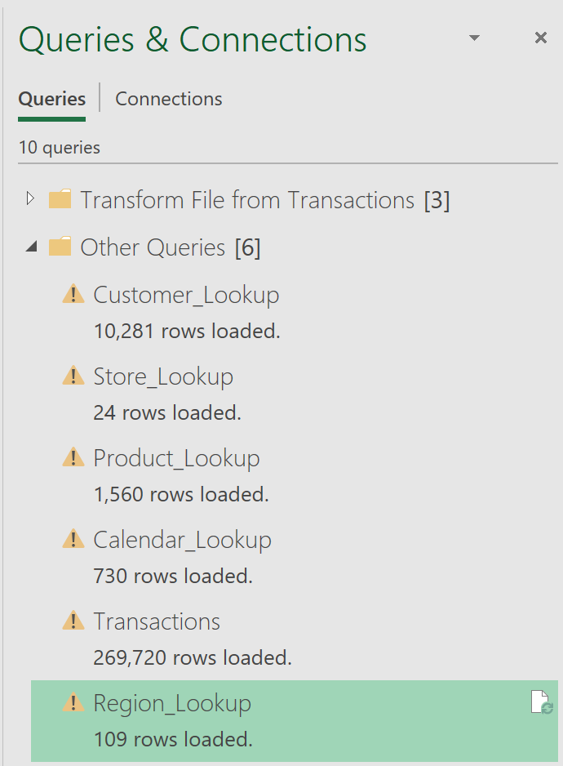



Import “FoodMart-Returns-1997-1998.csv” (You already know how to do this. Please see Week #2 exercises if you forgot how to do this). In the Power Query Editor, change the name from “FoodMart-Returns-1997-1998” to “Returns.” This process should ingest 7,087 rows.

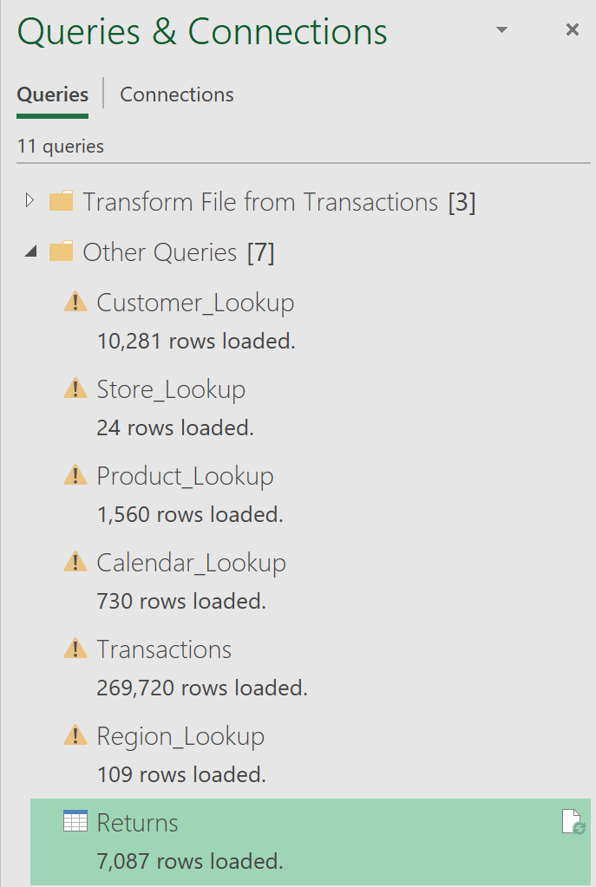



Go to the data model diagram view and wire up this new table (you already know how to do this based from previous exercises this week). Your ERD should look like the below image.

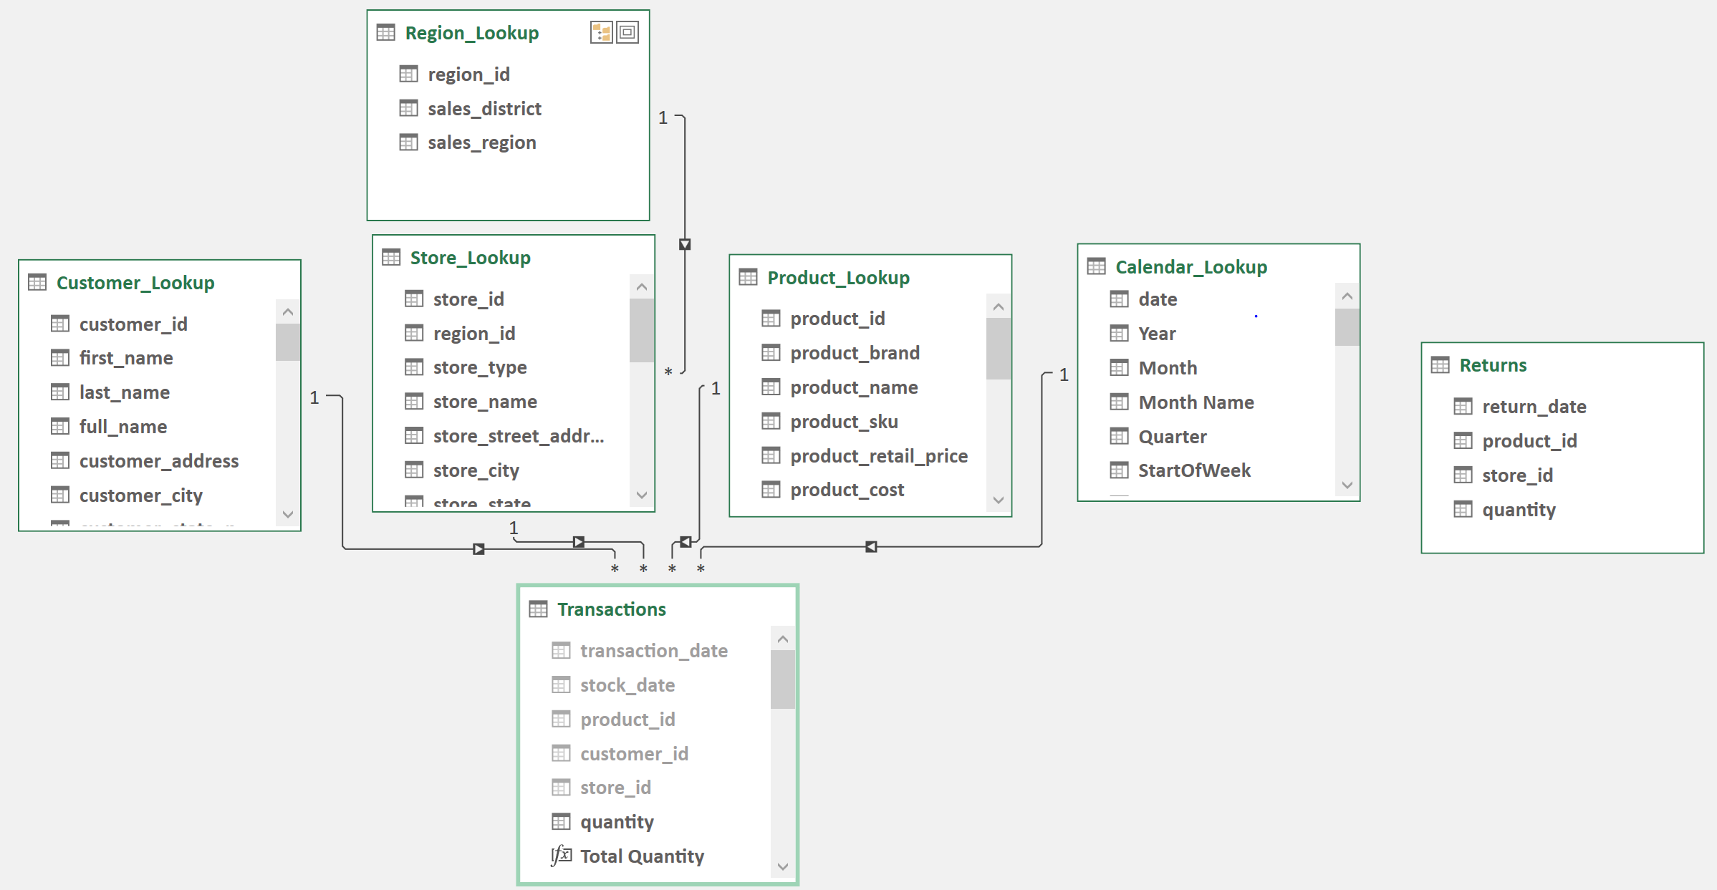

Rearrange your Returns table and build three relationships:

1. To Calendar_Lookup via return_date
2. To Product_Lookup via product_id
3. To Store_Lookup via store_id

After you build these relationships, your completed ERD should look like below.

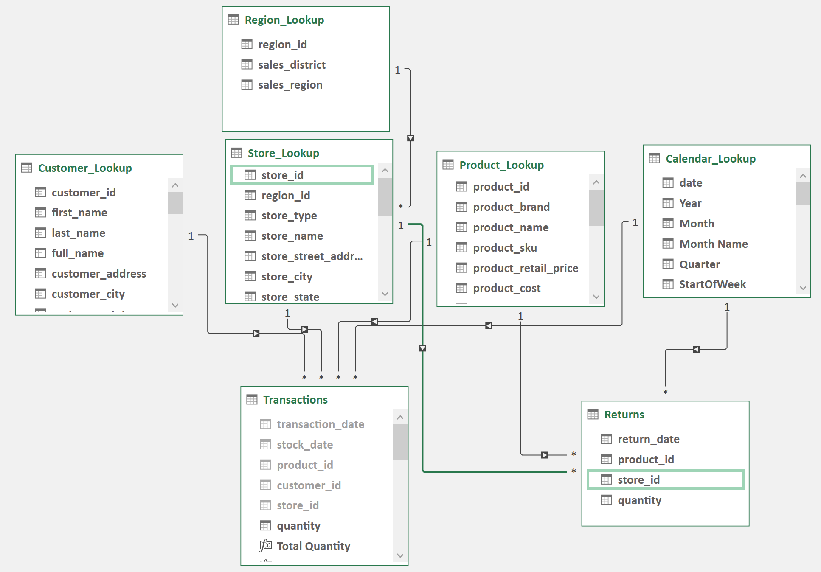



Save your work and reposition your screens so that Excel will be in the background and the data model window in front.

1. Take a snapshot using Window's Snipping Tool.
2. Make sure the system's date, your name, and the ERD of the data model’s diagram view are included in the image. The new Returns table should be visible with all its associated relationships.
3. Submit to Canvas in PNG format.

